Intraday Volatility Method (Discretionary). Target $500 profit per trade.

Posted - 02/11/2012 13:44:28
Intraday Volatility Method (Discretionary). Target $500 profit per trade.
Set up:
- Find equities having >= $2.00 intraday EMA (exponential moving average price range) over past 34 trading days; last closing price between about $30 to $125 per share; beta <= 0.7; average daily volume > 800,000 shares. Put these into a RadarScreen table with whatever columns of data you wish.
First scan with TS scanner to find up to about 950 candidates with above parameters excluding the beta.
Then copy and paste those symbols into Tradable Symbols indicator (loaded into RadarScreen) to further filter those candidate symbols.
A link to this indicator is below.
Set Tradable Symbols indicator's APR_Recent Days input parameter to 34. Leave the other input settings at their defaults.
Sort (double click)on the APR_Recent Days input column to get in sequence of highest to lowest value.
Select those symbols having $2.00 or greater recent APR and which are not rejected due to other reasons (Reject message on left in red).
For each of the viable symbols, look up beta at Yahoo finance http://finance.yahoo.com and keep the symbols whose betas are about 0.7 or less.
Exceptions to beta parameter: ETFs and ETNs do not have betas. Use common logic/sense to select those which do not necessarily follow the markets closely. Do not use ETFs and ETNs which are in effect market indices. Among those which work well, as examples, are UCO, FAS, ERX which obviously do not always closely follow the markets. Those to avoid, as examples, include BGU, BGZ, DDM, MVV, MZZ, QLD, QID, SDS, SSO, TNA, TWM, TZA, UWM.
Symbols which pass these filters are viable for this method.
Tradable Symbols indicator will additionally reject symbols which have had volume too low on too many days - in other words, with unreliable liquidity. Unaware of any other tool that can do this.
- For each symbol, set up one desktop containing Time and Sales window; 5 minute interval chart; daily interval chart; week interval chart; each with the default number of bars. Format bars to candlesticks. Add Keltner Channels All indicator to top pane of each chart. %R to middle pane. Volume Exponential Average indicator to bottom pane.
- Study, learn intraday cycles using the Excel spreadsheet at the link below. This spreadsheet is conceptual, no particular day matches it exactly and some days match it not at all. Be sure to set the spreadsheet's adjustment for your desired time zone.
Trade:
FIRST, at the start of each trading day:
- Check the earnings schedule for each individual stock, at Yahoo!. You might skip symbols a week before their earnings announcements, to avoid getting trapped by rumors and leaks which are negative most of the time, and trapped by negative earnings surprises. On the other hand, it helps if there are positive rumors and leaks. Usually if a firm beats the street expectations, its stock will soar, whereas if it misses expectations it will plummet. Earnings projections also impact the stock on the day and day after of the announcement.
- Another fly in the ointment is "The Motley Fool". Majority of its articles are negative. Tends to drive an individual equity symbol down for one to several days, when it issues an article. Tends to make its negative comments self-fulfilling prophecies in the short term. Check premarket on Yahoo! for each symbol, to see if the "Fool" has just assassinated any symbols you intend to trade - whether using this method or any other. Avoid symbols with "Fool" articles about them within the past week or so and especially the days on and after the "Fool's" attacks.
After the above two checks, then trade as follows:
- Buy 1,000 shares at a low price between the open and 10:45 AM Central. Much of the time, the best prices are between 9:15 AM Central and 10:30 AM Central. May be bought in any multiple of 100 shares, depending upon liquidity.
- Sell 1,000 shares after price has risen $0.52/share, the two pennies to cover commissions. May be sold in any multiple of 100 shares, but once you decide to get out, get out as fast as you can.
- Price will not necessarily bounce up $0.52/share. Exit regardless by 12:35 PM Central. Exception: on a moderate to strong bullish day, use a tight trailing stop, or visually monitor to exit, let it run to a larger profit. Do not let the price gain drop below $.52 on such a day. Once profitable do not let price drop into a loss.
- Does not matter much if markets are up, down or flat, providing entry is at a sufficiently low price. Providing you stick to symbols whose beta is <= 0.7. Exception: those exceedingly rare days when the markets start down at the open and continue down through 12:35 PM Central. Take the loss at 12:35 PM Central or before.
Advice:
- Emotions: do not get elated or discouraged during the trading day.
- This method works well a high percentage of the time but not 100%.
- Be patient. Be VERY patient when trading this.
- Often the lowest prices of the morning are between 9:30 AM and 10:30 AM Central. Study the history of each symbol to see if there is a recent repeated pattern of such lows. Often the highest price is at 12:35 PM Central followed by a decline. Sometimes, not infrequently, prices rise around 1:00 PM Central, a bit more often after 1:30 PM Central.
- Watch %R, Vol indicator, KC for visual clues, which with practice will become obvious and instinctive.
- Do not get greedy. Often you will leave $ hundreds, and rarely even $ thousands of profit behind. Train yourself to have no regrets. The objective is to gain up to $500/trade, slow and steady, day after trading day. Get greedy and like any method, inevitably there will be a large loss coming with your name on it, perhaps a long string of losses.
- This is a high win rate method with relatively low risk. If you are not achieving 80% to 93% win rate or if you are suffering a large loss once in a while, then you are probably not trading with sufficient self-discipline, and/or too impatiently and/or not paying enough attention to/understanding the indicators. Or gambling greedily by buying more than 1,000 shares per symbol per trade – which is poor risk/money/position sizing management.
- Judgment is required for entry and exit, watching the indicators and time. This is not a good candidate for automated trading. It appears to be simple enough to automate, but trade this manually for a month or so, and you will see why this is not such a good automation candidate.
- If something about the day, charts, etc., does not instinctively seem right, don't trade. It is perfectly fine to sit on the sidelines for a day, a week, a few weeks. I do it. A better trader, Larry Williams does it. Jesse Livermore once said that he made more money sitting in cash sometmes than when he was trading. It is GOOD to sit on the sidelines sometimes, not bad.
- Trader beware. There is more to this than what I have described. Easily learned by simply studying the charts and sufficient practice trading.
- Deviating from the above may result in otherwise easily avoided losses. Symbol selection is critical and DOES require use of RadarScreen and the Tradable Symbols indicator. The TS scanner is insufficient. Am unaware of any scanner on the Internet which can scan as well as RadarScreen and the Tradable Symbols indicator. Manually look up beta's on YHOO, does not take very long. TS beta values are on a different scale than those at YHOO. Including bata in a TS scan will exclude ETFs and ETNs, an undesirable effect.
Links:
https://community.tradestation.com/discussions/Topic.aspx?Topic_ID=36865
https://community.tradestation.com/discussions/Topic.aspx?Topic_ID=36820
https://community.tradestation.com/discussions/topic.aspx?topic_id=18787
https://community.tradestation.com/discussions/Topic.aspx?Topic_ID=36561
Addendum trade rules:
- One trade per symbol per day. Do NOT exit then get back in.
- OK to scale up entries, but not to more than 1000 shares per symbol. OK to scale down exits, although most of the time it is best to get out fast, especially if it is not at least a modestly strong or better bullish session.
- Once exiting has begun, continue until done. Do NOT add to a position once exiting has begun.
- Do NOT carry overnight and especially do NOT carry over a weekend. This is an intraday trading method, NOT a swing trading method.

Posted - 02/11/2012 18:43:40
Stratman, since late 2000.
Back then I subscribed to the only consistently profitable trade pick service in my experience. For $75/month, a guy provided two picks each trading day before 7 AM Central. His instructions were simple: buy 1000 shares at the open, close at $.50 or greater per share gain. He purposefully limited the number of his subscribers to something like 100 so that fills would work. I sometimes wonder how much of the stock price rise was due to the concerted actions by us 100 subscribers.
What I could not figure out and what he would never tell me, is how he made his picks. They were always ones in the news about something the day before, but there was more to his two picks than that. He was officed in NYC Twin Towers, never knew his name, he may have died on 9-11.
One day (late December 2000) one of his picks went up $13.00+ per share and the other went up $4.00+ per share. I was trading at the local Terra Nova brokerage site with Realtick. Just as I was literally hitting the enter key for both trades a couple minutes before the opening, both of the office's Internet connections failed (again - primary and backup both). Missed a sure $15,000+ profit.
Never again traded from a brokerage office. Less than a month later had a really bad episode with RealTick from home, which motivated me strongly to find the best broker-data feed-software combo, so after very extensive research and analysis, switched to TradeStation...so if you recall my frequent defenses of TS when someone's own PC and own network were the problem, almost always not TS, that was why I defended TS, no comparison, TS was almost infinitely more reliable and faster than its only serious day trading competitor, RealTick. (Anyone besides me notice that virtually all those supposedly TS issues have disappeared as PCs have gotten enough memory and speed for even the least capable desktop and laptops?)
Back to this method, commonly this guy's picks went up far more than half a buck a share. The picks were traded long only. Remarkable, if you look at the markets back then and well into 2001, this was during a nasty bear market.
Anyway, had to come up with my own picks, per above. Also polished his method up. If he is still around (hope so!) still wish he'd tell me how he did his picks. He stopped providing the service a little before 9-11. And I'd sure like to thank him and shake his hand.

Posted - 02/11/2012 18:50:08
TradingDude, I do consider opening gaps in this method, and in other methods, since they often close during the same trading day.
If a symbol in this method opens gapped down, it is a great and strong clue to hold on for more than just the $.50/share gain. Often when a symbol gaps down at the opening, from the prior day close, it will bounce around a lot for the first 15-30 minutes, then it tends to settle down in a very narrow range. I have another method for trading this kind of pattern, which I will post soon. And often but not always, after a few hours flatlined, the gap begins to get filled.
Note above that the symbol selection criteria is based upon intraday price range and NOT, on purpose, True Range.
Daily TR is useless for intraday trading, whereas daily PR matters a lot. TR takes daily gaps into account, using which would distort what the actual intraday price range is, of course.
Since this method does NOT hold overnight, the closing to opening day interval gaps are irrelevant for calculating the intraday trading price range.

Posted - 02/11/2012 19:18:38
StratMan, this may be such a method, was unaware of the post/thread you mentioned. If, big IF, a trader follows the above, and executes an exit at a small loss early rather than letting it grow to a large loss, this is a high win rate, low risk, easy pickin's method. Providing the trader NEVER holds these trades open overnight.
As a retired guy almost 70, I find this method totally stress free, virtually riskless, boring even.
Have another one, low risk, high win rate, which I'll share soon.
No one asked, but why am I sharing some of this stuff finally and now? Pair of health issues, thought I'd better share some of what I know while I still can.

Posted - 02/12/2012 14:52:12
Regarding actual trading results using this method, plus some other methods...Jan 3, 2012 through close Feb 10, 2012:
My account's net worth increased 19.31% so far in this 5 week period. If I had played a few trades smarter, which I could and should easily have done, would be up more than double this.
And I did not trade ten days in January, because we had to travel for the funeral of my wife's mother. On the days I did trade, spent no more than two hours per trading day, off and on, at the PC.
Not bad for three weeks trading, part time hours.
Keep in mind that you can make multiple simultaneous trades with this method, using different symbols.
If you try this method out, please post your experiences - difficulties, mistakes, successes and results - herein - so that others can learn.
I will share another method after several traders have done this. No point in sharing more, though, until at least some have succeeded with this one, which is the easiest to learn to trade well.

Posted - 02/13/2012 09:20:43
Up 3.33% in first hour premarket this morning, am quitting for the day rather than tempt fate. Back completely in cash, so profits are real.
Used a different method that I may also share some day, besides the one above and the second one promised if enough try out the above one and report results, good and/or bad.
split, I first use TS scanning to cut the prospective list to under 1,000 symbols, for a variety of methods.
Then I use a custom filtering tool to create lists for each method I use. This tool is at https://community.tradestation.com/discussions/Topic.aspx?Result=1&Topic_ID=36561
I usually use 34 days, but 21 days probably works about as well.
It does not scan for beta. I simply reduce the number of candidate symbols to the best 35 or so, then manually look up their beta's at http://finance.yahoo.com
Only do this once every 60 to 90 days. Data doesn't change that much to make scanning more often worth the time.

Posted - 02/13/2012 09:45:55
split, regarding drawdown...
For vast majority of trades, drawdown is a dime or less per share. Fewer than 10% of the trades drawdown 50 cents per share, and almost all of those I close at that point. On higher priced stocks, if I entered early and nothing spooks me, on very rare occasions I accept a DD of a buck per share, but with this method never let it draw down more than that.
Regarding the prior 4 weeks, that would be December. Did not day trade much in Dec, too busy with family, especially our supercute grandkids. Did swing trades. Did well but not as well as this year so far.
A comparable period would be the first half of last year. Trading only occasionally, account was up 40%+ by mid-year. I shared this in a thread or two back then, don't remember which threads.
In July last year I went on vacation and forgot (diabetes and medicines I take for it give me short term memory problems) to set stop losses. Packed, knew I was forgetting something, and on the drive to Kansas City from Dallas, remembered near OKC that I had forgotten to put in stop losses. Got nailed on my open swing trades, especially in crude oil, during that sharp July market drop. Stopped trading until around November, ticked at myself, and got busy with other stuff. Everyone does dumb things like that, just a matter of trading long enough...finished the year up nicely, but that memory lapse really hurt.
To clarify this a little more, I always have a stop loss and profit target - in an Excel spreadsheet - for EVERY trade.
When I'm going to be away from the PC for very long, I pre-enter stop loss and profit target orders on all open positions.
Have an easier time manually executing stop losses when those levels are hit, than I do profit targets. Too often I do not stick to the profit targets and get edgy, taking profits too early (hence my comment above, that I should have done twice as well already this year).
Usually do not enter stop loss orders in advance because there are too many times when some SOB hunting for "MY" stops , catches one with a spike down. So I manually manage these when at the PC, wait to be sure that the stop loss hit is not going to reverse up quickly, before exiting.
One more caution. About 1/3 of these trades do not increase by half a buck per share. Some top out at $.25 to $.35 per share, some at even less. If resistance has been hit below the target profit, and seems to persist, take the smaller profit.
This method, and a handful of others, do very well, when I avoid bad mistakes which are not part of the methods. If you stick religiously to what I posted, you should do well with this method. How well, depends upon your capital, how many simultaneous trades you can safely manage. And how religiously self disciplined you can be.

Posted - 02/13/2012 10:26:55
Another thing I simply forgot to mention, which helps this method a lot, and any other discretionary method a lot, for that matter.
Each symbol has its own unique personality and patterns over the short term - days, weeks, months. Like all things in the markets, there are human based reasons for this.
A symbol usually has the same market specialists/market makers managing its liquidity.
A symbol usually has a number of the same intraday traders trading it.
A symbol probably has the same institutions investing in it.
A symbol usually has the same earnings announcement and news updates cycles.
A symbol for a company has the same executives, employees, profit sharing plans trading and investing in it, in repeating cycles - pay days, quarterly bonusses, options and the like.
Best to become an "expert" in a relatively few symbols, learning their patterns. These patterns often repeat on similar days of the week, days of the month. This applies equally to individual stocks and to ETFs and ETNs.
One of my currently favorite symbols (don't ask, some things I won't share) has a tendency on many days to open gapped up or down, then to close half the gap or more, then to channel most of the rest of the day until 40 minutes before closing. Then it goes up or down. That closing direction is where it often opens the next day, gapped up or gapped down. I trade three different methods with this one, two are intraday, and one is swing trading.
Learn the behaviors, patterns of each symbol you elect to trade. Specialize in it. Different methods work better on some symbols than on others. When you find good matches for method(s) and symbol(s), you've found a money machine.

Posted - 02/13/2012 20:52:28
ant_ as explained earlier in the thread, this is my modification, updating and enhancement of a defunct stock picking service's method from back in the wild super bull market days circa 1997-2000.
Recommend reading all of the posts in the thread in sequence. Very good questions asked and answered.
It is profitable for me. Hope it works well for others herein. As you know with your long experience, a method which works great for one trader, does not necessarily work as well for another. Only way to find out if it will work well for you, is to do it.
On the surface, it is simple - but it has many nuances. Its premise, basis, is simple - take advantage of intraday partly random partly not random intraday cycles and volatility of wide ranging stocks, ETFs and ETNs, intraday, with relatively low risk and psychologically satisfying high win rate, once mastered.
Thanks for your kind comments.

Posted - 02/14/2012 11:24:28
For those trying this out today, it is a perfect day for it. Markets down a little at open, down some more, now reversing up.
Use your own judgment. However, depending upon your entries, this "smells" like a day which will end up maybe 50 DOW30 points, from the low less than an hour ago...thus, for most symbols should earn more than $.52/share profit. Wisest is to exit by 12:35 PM Central, but often on a pattern like today's, the markets dip then, followed by a move to a greater high roughly 10-40 minutes before close.

Posted - 02/14/2012 12:58:41
Pattern today running differently than I expected. Because of Valentine's Day? Usually there is a move up at lunch time on days similar to today.
Maybe many at lunch with their sweethearts or out panic buying gifts at lunchtime?
Could be that many will stop trading early today for similar reasons.
My guess is that may mean those holding shorts will close out early, causing a small to modest, brief move up before 2 PM Central.

Posted - 02/14/2012 17:49:56
Last time I ran the scan (TS followed by the Tradable Symbols RS tool), on Jan 24, without beta, got 34 symbols FWIW. Then looked up beta's on YHOO. With beta should be between 4 to 12 symbols, varies from time to time.
Eventually you might do as I do, and continue trading some symbols which once fit this scan, and turned out to be very good for this method, but which do not show up in current scan.
There were 819 symbols in my initial scan with TS's tool, which included price as low as $15, because I create multiple lists - one for each kind of trading.
Filtered these more with Tradable Symbols RS tool. For my purposes, results provided
- 738 suitable for swing trading methods (used ATR, not APR on both TS and the TSRS tool);
- 492 for intraday trading methods (used APR not ATR); and
- 34 for channel volatility trading (APR not ATR) - the next method I will share if enough try this one and report results.
If your scans do not provide enough candidates for your purposes, increase the beta a little until you have enough. The purpose of the beta is simply to find symbols which are more likely to not decline as much if at all, as the markets do, on down days.
Low beta symbols trade well for other methods. As an example, last week, for one of these symbols, CERN, beta 0.69 on that day (0.54 today), I bought several thousand shares during the day of its evening earnings press conference, at about $62/share. It rose to over $70/share post market, the rise began while the press conference was still going on, and rose the next day to over $71. It is my most profitable trade of the year so far. But not using the method in this thread, using a different one.
Always seemed odd to me that most traders and investors seek high betas, when the opposite is often more rewarding. OK by me what others do. Am a contrarian by nature and I prefer to fish where the fish are better, and where there is less competition.

Posted - 02/14/2012 21:23:13
Here are the symbols from my scans from about a month ago, excluding beta filtering:
AGQ, CLF, COG, CTXS, DECK, DMND, EDC, ERX, AS, FSLR, GMCR, HP, IDCC, JOY, LULU, NFLX, OPEN, PANL, PXD, QCOR, RRC,SHLD, SINA, SLB, TNA, TPX, TVIX, UA, UPRO, VMW, WLT, WPI, WTW, XEC.

Posted - 02/14/2012 22:12:24
Have to run an errand tomorrow morning, won't be available for about 2 hours during mid morning. Just FYI in the event anyone has questions then.
Unfortunately I did not anticipate that the scanning and filtering would be difficult, or that some would not be using RadarScreen or not be familiar enough with RadarScreen to use the Tradable Symbols custom indicator. Sorry for my lapse! Just that I do not want folks dependent upon me for symbol selection, as I was dependent upon the guy whom I learned from, for symbols.
Hope everyone who is trying this, can now get past the symbol discovery phase and into simulation and/or live trading phase.
If live trading, best to begin by trading only 100 shares for one symbol, until gaining enough practice, confidence and experience, to risk trading 1000 shares safely for one symbol, and after that, for multiple symbols. If you feel stressful when trading this live, then may be worthwhile doing more simulations first. This should quickly turn into boring but profitable, stress free trading.

Posted - 02/15/2012 12:11:29
Yes, split, I trade the same symbols for months, sometimes years. Oddly the beta seems to change faster than the other parameters. Same symbols tend to show up again in scan after scan.
Have not traded yet today, may skip altogther. Saw good entries at 9:30 Central or so, but could not stay to monitor trades. Had to run errand for couple hours this morning.
Bear in mind that you do not have to get a bargain price for this method to work well, with high intraday APR stocks. The intraday cycles and wide APR almost always take care of that. Yesterday started out looking like a perfect day for this method, but probably because of Valentine's Day, intraday cycles did not behave like they usually do, around lunchtimes. Method works on vast majority of trading days, but not always, nothing works well always in the markets.
Starting in an hour or two will enjoy baby-sitting our three grandsons (ages 13 mos; 2.75 yrs; and 6 yrs) for rest of day. Impossible to trade with them here. Also will get them tomorrow all day. Time invested with them is infinitely more valuable than trading profits.

Posted - 02/15/2012 12:24:22
ALXN good entries at 9:30 (Central) around $82.65, now trading at $83.86.
NFLX good entries at 9:30 around $121.70 now trading at $124.09.
PRGO good entries at 9:30 around $94.35, rose to $94.85 around 10:50 am, although now trading back down around $94.46.
RRC good entry at 9:30 at $63.00, rose to $63.55 and thereabouts multiple times, now trading around $63.39.
Each one worked fine today. Easy $2000 if you had traded them, Tom47. And you could have made lot more with the first two.
And now you would be in cash, free for the afternoon, with no worries about carrying open trades overnight.
How does that song go..."I'm a believer..."?

Posted - 02/15/2012 12:44:30
ant_ if you mean entering at the open, no, I rarely do that for this method.
(Entering at the open was what the stock selection service guy recommended back in 1999-2001, but that is not for my variation of this method.)
Most often for this method I enter between 9:15 to 10:45. Best seems often to be between 9:30 to 10:30 Central.
(I trade several other methods some of which have different entry times.)

Posted - 02/15/2012 12:45:21
Yes ant, all times I mention in this thread are Central.

Posted - 02/15/2012 12:50:47
Check OPEN. Nice entry at 9:30 today at about $45.00. Traded as high as $47.65, now at $46.73.
Notice that these LONG trades make $$$ when the DOW30 is down. This is the reason for the beta parameter.

Posted - 02/16/2012 00:04:25
kevinkdog, I look at daily charts and intraday charts for the symbol, look for support levels. Don't have time to do that for these, but you should be able to see those yourself.
An alternative is to use money/risk management rule of thumb. One to two times the possible gain as a stop loss, only that high because this is a high win rate method (usually is is half the expected gain). So, use .50 to 1.00 per share as discussed earlier in this thread, depending in part upon the price per share.
An alternative is to concentrate on the time of day and intraday reversals and how price is behaving with respect to those tie cycles, rather than having a priced based stop loss. Study the Excel spreadsheet referenced early in this thread to learn the typical intraday reversals. If those do not occur that is a clue that the trade might be going bad.
Clearly what you suggest above would be far too tight, as by entering between 9:15-10:45 most of the time you will be entering near the low of the day.
As to what I would have done, either support and/or the .50 to 1.00/share, and it did not matter at all as it turned out, neither stop loss method/level was approached after entry.
- - -
Intraday trading requires quick decisions and quick actions. Intraday hesitation turns a winning trade into a loss...getting in too late and out too late. There is not enough time intraday to analyze and study - decision must be done in less than a few seconds followed immediately with action - entry or exit.
This kind of trading is NOT suitable for anyone who is a cautious swing or longer period trend trader, even though it is a high win rate method - for as can be seen today the entries were against the intraday trend, and often are.
A trader should only trade those methods which are compatible with his/her personality, risk tolerance and capital. If trading this method is more than slightly stressful, then it is probably not good for that trader, and s/he may lose money entirely through slow decisions and slow actions.

Posted - 02/17/2012 14:14:19
Gratifying to see so much sharing and learning going on herein, as an incorrigible teacher.
This thread is kind of like the threads we used to have back in 2002-2004, then we got away from that. We used to share lot more about trading, TS, RS, markets.
One reason I suppose that ended to that degree, is that many of us wrote ourselves out of things about which to write.
Another reason is that many of those traders are no longer active in the forums - no longer using TS or no longer trading or retired or whatever.
When searching in TS forums, be sure to check the Search Archives option, there is quite a bit of trading wisdom back in those 2002-2004 threads.

Posted - 02/17/2012 14:39:24
We are nearing DOW30 13,000.
- Markets may hang around that level for a while. Seem to have trouble getting over 1,000 levels and staying there. May be an especially good period for this intraday method and for intraday channel trading methods.
- Markets are due for a significant correction, obviously. Holding anything overnight and over weekends is becoming increasingly risky. Correction could be triggered near 13,000 level, but I suspect it may not occur for a few to several weeks yet.
- On weekly charts I see fair number of symbols well underway to forming the cup or saucer part of that bullish pattern. What I also see is, maybe several more up weeks, followed by a sharp drop down, then back up, forming the handle, then some stagnation, then up we go some more like the typical cup or saucer and handle pattern. None of which may happen of course. Might. Might not. Something to watch for and take advantage of, if/as it happens.

Posted - 02/17/2012 16:55:30
Yes bwjr I do but on the intraday chart. On the day and week chart, I look for support, resistance, sometimes the preponderance of red versus green candlesticks, sometimes geometric patterns, etc. But mostly just the intraday chart and the time and sales window.

Posted - 02/17/2012 17:42:00
RGLD is not on my scanned list of trade candidates, bwjr. Be careful to use this method ONLY on the symbols filtered per the parameters provided in the initial explanation of this method.
Went back and saw it on the scans of one or two others, but it is not in my group. Nor are LO, MNST, EW. My filtering run was over a month ago. My guess is that some scans are not using 34 for the EMA's for APR, as I do. 20 or 21 EMAs are probably ok but not shorter ones.
Use the Tradable Symbols indicator with its default settings. RGLD is rejected therein, someone else has reported.

Posted - 02/17/2012 18:51:39
Here are the ones scanned on my list of a month ago, with beta's at or under 0.7 as of this evening, as well as ETFs which do not have beta's but which do not necessarily follow the market closely:
ERX (ETF)
FAS (ETF)
GMCR (beta 0.64)
IDCC (beta 0.83, think it was lower a month+ ago)
NFLX (beta 0.48)
PRGO (beta 0.73)
RRC (beta 0.7)
"Grandfathered" in from prior scans, but which do not necessarily fit now - trader beware:
ALXN (beta 0.36)
CERN (beta 0.54)
OPEN (beta 0.99)
PANL (beta 0.9)
UCO (ETF)

Posted - 02/17/2012 19:05:53
Maybe 21 is too short, we should apparently stick to 34, my bad.
Don't know why EW did not show up in my scan a month+ ago but it did not...maybe something in the Tradable Symbols settings rejected it back then. Regardless, don't like its intraday pattern right now.

Posted - 02/17/2012 21:30:05
Yes, I am using YHOO's beta. Don't know anything about TS's beta.
Scanning with TS's beta parameter included, will exclude all of the ETFs and ETNs, which do not have betas. ETFs and ETNs are filtered manually with judgment, knowing what follows the markets closely and what is independent. BGU, MVV, other index based EFTs obviously follow the markets. UCO does not. FAS sometimes does, sometimes does not. Etc.
Devil can be in the details in scanning. Symbol selection is an important part of this method. Symbols are not static but once every couple months to once quarterly is sufficient.
Not saying other scanning parameters won't return viable symbols for this method. But skipping steps and using different calculation methods may result in getting symbols which don't work so well.
Only the parameters I provided (and using 34 EMA length) work well, including manually looking up beta in YHOO - which doesn't take very long for 35 or so symbols from TS then Tradable Symbols filtering.
Notice that Tradable Symbols RadarScreen tool uses EMAs not SMAs. And both APR and ATR.
If you do not subscribe to RadarScreen, it is very valuable when trading stocks. Recommend learning to use it well.
Important to learn to do this by yourselves, it is never a good thing to depend upon a source other than yourself, beyond the period required to learn a method.
FWIW I did not post my trade results for today because I was too busy with other stuff to trade...and Fridays are when I make my worst trades.
Monday is not all that major a holiday, but there is a holiday cycle, which is: week before a major holiday is usually up (sometimes excepting the last afternoon), and the week after is usually down.

Posted - 02/20/2012 20:35:45
Just an observation. Too much tinkering around and not enough simulated and real trading going on.
Bluntly, before trying to improve this method, why not first learn to trade it, as-is, well? Maybe the method can be improved, maybe not, but until a trader truly masters it, as-is, tinkering with it is a waste of time.
Perhaps the tinkering is a form of procrastination, a fear of real trading, a fear of failing at trading a method which works, or even a fear of succeeding wtih a method which works.
Well, know thyself is an important issue for a trader. Don't trade this method if you're afraid of it. NP, less competition for fills for my trades then. Or trade it, but be smart about it, master it as-is before being presumptious about improving it.
What I'm saying in other words is, too much diversionary, distracting stuff herein. Time to trade it or get off the proverbial pot. It is not time to improve it before even really understanding it.

Posted - 02/22/2012 11:25:51
ant, beta matters on down days, and down part of up days. On up days, does not matter. I simply keep trading symbols which worked well in the past, and which passed the screen sometime in the past...keep trading until they fail.

Posted - 02/22/2012 18:48:02
theHook, some institution(s) and/or execs were dumping the stock today, is why it went down. Now, why they were doing that, have no idea. Saw, read the Samsung news but nothing negative at all about PANL for weeks at least. Could be a fund of some kind, decided to take profits. Since the dumping continued through the close, might continue tomorrow. It has been a good symbol for me to trade in the past.
PS: Looking at weekly chart this evening, looks like PANL has been going down since its last earnings conference, obviously some large holder(s) taking profits. That does not normally matter for this method, excepting that, unusually, the shares were sold all day long after the opening, instead of the more intelligent method of letting price rise back up after selling some. Maybe it is near the end of the selling, don't know. Probably won't be trading PANL again until the institutional selling eases up or stops.

Posted - 02/23/2012 13:27:20
Closed profitable channel trades in OPEN and RRC.
bwjr, I use only Intelligent routing. Limit Day orders unless I am trading pre or post market. To get fills, buy at the ask and sell at the buy, if you fight for a penny or two, too often you will not get filled.

Posted - 02/23/2012 14:06:03
Desktop set up including time and sales
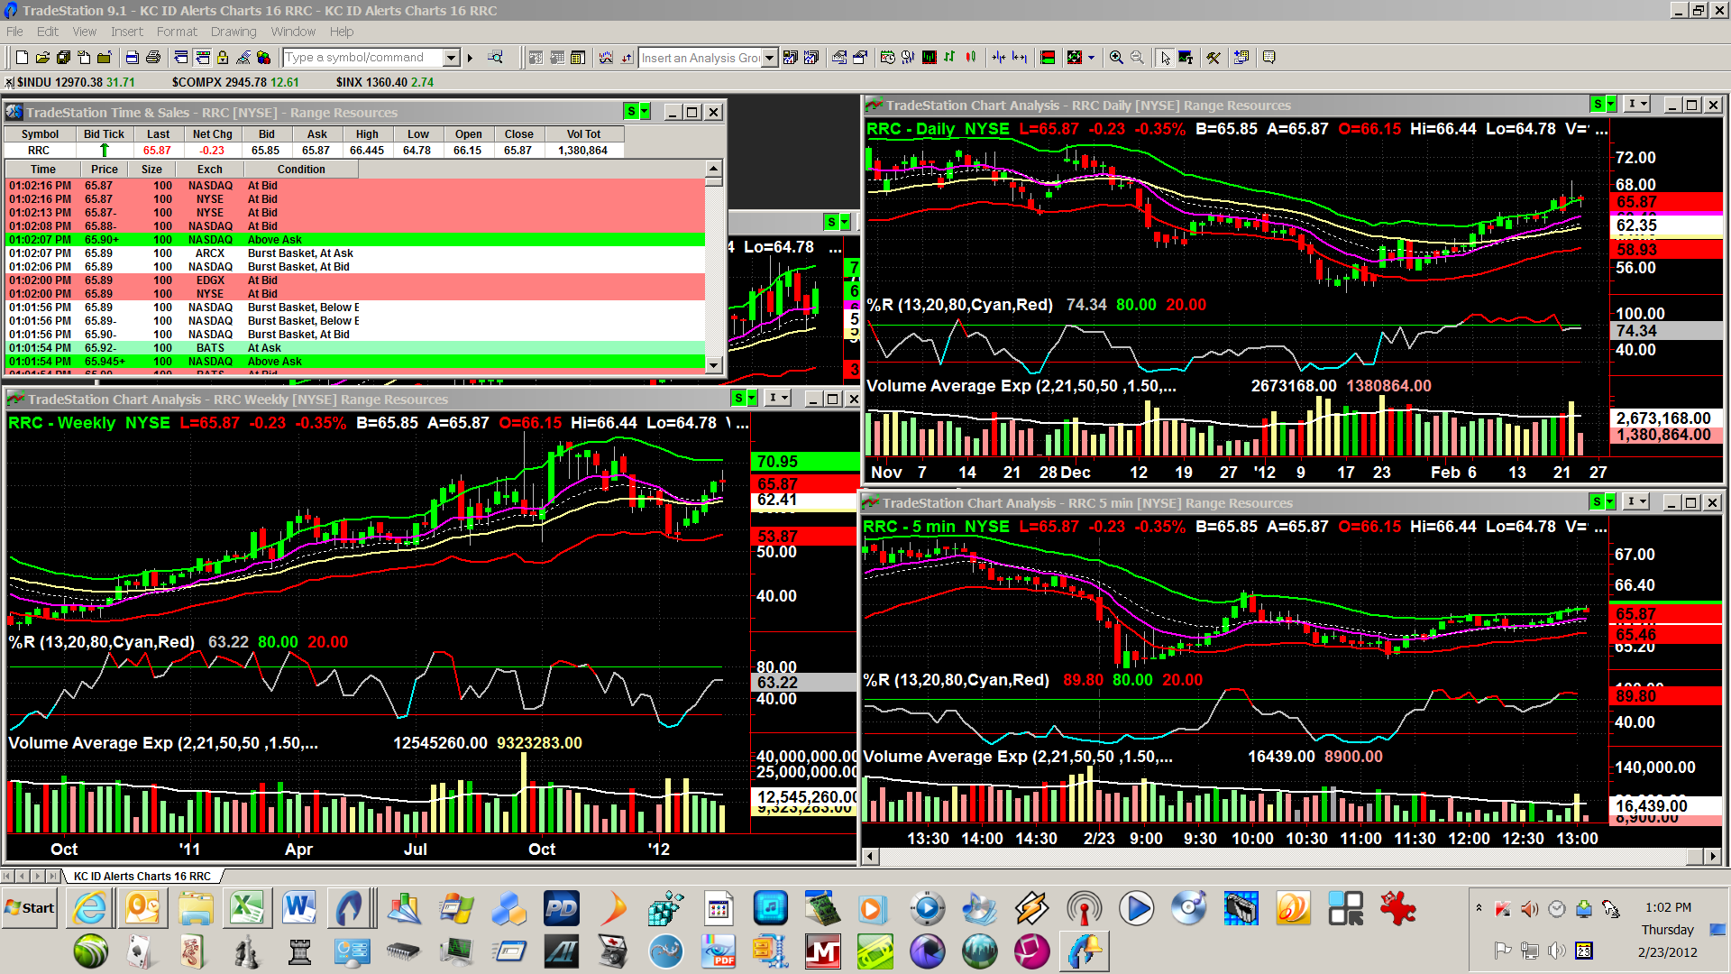

Posted - 02/24/2012 13:38:38
Closed profitable trades IDCC, NFLX, RRC, only trades today. Back totally in cash for the weekend. Good enough for a Friday, which is my nemesis too often, taking rest of day off rather than tempt fate.
ant, groh1, I leave the interpretation of the charts and indicators and T&S to each herein to learn and study on their own.

Posted - 02/26/2012 15:11:39
Lloyd, see my earlier comment, in effect, you must figure some things like this out for yourself.
ottrader, it is not always best to trade in increments of 100, as you will see in my next. There are valid reasons to trade in odd lots. For example, fills for odd lots are given extra scrutiny for fill compliance. And, calculation of max position size may be rounded down to 100 shares, but if max position size is less than 100, then so be it, it is either don't enter the trade, or stick to the max position size calculation of under 100 shares.

Posted - 02/27/2012 02:48:31
I moved the breakout post to a separate thread, rather than clutter this one up and bury the breakout stuff where it cannot easily be found. The new thread is at https://community.tradestation.com/Discussions/Topic.aspx?Topic_ID=118289&PAGE=1
The breakout stuff is not the second trading method which I will share later, after enough results, experience with this intraday volatility method are posted herein. The one for later is a channel trading method.

Posted - 02/27/2012 19:11:10
ant, whatever works, works.
groh1, piece of cake to monitor about 60 at once, but more commonly 45 or so when I'm swing trading and intraday trading simultaneously...providing no grandkids to baby-sit on such days. Partly via RadarScreen - for open trades and for potential trades not yet entered. Partly lots of desktops, workspaces, charts. Partly placing stop loss and profit exits right after entering, bracketing each open trade so they do not need much if any monitoring.
Well, made some money today but had two small losses with this method: RRC and OPEN. Both were profitable at less than target, at points in time, but could not sit at PC to monitor so did not get out in time - happily busy with grandkids.
Behavior today concerns me, meaning behavior around DOW 13k. Kept selling off whenever 13k was touched or crossed, perhaps a lot of automated profit taking?
Suspect that it would not take a whole heck of a lot to get a significant sell off going.

Posted - 02/29/2012 10:39:47
Closed PANL at .52/share profit.

Posted - 03/01/2012 11:37:40
cam, frequently carrying over works out...that is bad...because it reinforces doing it again....but..for all those times it does work out, it only takes one very bad loss to wipe out a whole month or two's gains. You have arrived as a trader when you can take the losses caring far more about having stuck to your rules than a small twinge about the loss.

Posted - 03/01/2012 21:00:34
Those are not trades per this method, cam.
Add these to your trading rules, cam:
1. Once a position is closed do not trade that symbol again during the current sesssion. This method is one trade per symbol per day.
2. Multiple entries into the position are ok but only to a total of 1,000 shares. Multiple exits are ok, but once exiting has begun, do NOT add back to the position, keep closing the position until out.
3. Only trade the symbols which pass the screens. LULU does not. QCOR does not.
It sounds a bit like you are trying to channel bounce trade but by guessing rather than by understanding the patterns and what to do with them. Since this is a method I may share next, and is a much more difficult method than this one, you might consider waiting and building up your account with this thread's method.
Or, you may be seeking some excitement.
If this method is boring for you - yes, it is boring, once mastered - be advised that good trading IS boring. Be an automaton when trading for profit - a bored automaton.
For excitement, sky dive or gamble in Las Vegas or drive race cars or whatever, with your profits from boring trading. But excitement and trading simultaneously is a bad mix.

Posted - 03/02/2012 15:12:12
ALXN +.52 closed.

Posted - 03/03/2012 13:05:47
Looking ahead:
Week of 3-5 have no strong opinion. Best weak guess is flat to down. Mondays often go the opposite of the rest of the week.
March, April, May are usually up overall.

Posted - 03/06/2012 12:56:48
Guess I "picked" as good as time as any to have stomach virus yesterday and today.
Method does not work well when markets are down this much. When DOW is down 50 points or so, there are swings up which tend to follow the intraday cycles, matter of timing the lows and reversals up. But not on a day like today.
Significant correction has been due for weeks now. Don't know if this is it, or enough.

Posted - 03/08/2012 17:12:59
Biopsy today. Only one trade, RRC, +.53.
Hasn't been at least a month yet, migleve. Am a little surprised at how some have had some trouble with this one. Next one is much more difficult to trade.

Posted - 03/09/2012 10:40:39
UCO +.50. Only trade today due to health.

Posted - 03/09/2012 12:57:34
The lack of observations and comments on one aspect of this method herein, TIME/TIME OF DAY, may mean insufficient attention and understanding of it.
This method is based upon repetitive human behaviors and human actions with respect to time: cycles caused by humans.
- That is why it has worked for so long, and why it will likely work for decades to come.
- That is why we have not interferred much with each others' fills even though trading a relatively small number of symbols.
- That is why I had/have no fears about losing any of my own profits by sharing this method.
Markets are driven by combinations of random and non-random actions, scheduled and unscheduled events. Traded properly, this method takes advantage of all of these, excepting only those unscheduled events which go against it.
The deeper the method is understood, the better it can be traded. It is like an onion, multiple layered.
Don't just look for magic trigger points in price, or price and volume, or the indicators.

Posted - 03/15/2012 10:23:55
Wins with this method today .52/share or better: SHLD, PXD, PANL, NOV, UCO. No losses, no break even trades, only latter with this method today.
Traded higher beta symbols (which otherwise fit all of the selection parameters) because I saw an early bounce up coming and because none of the low beta symbols looked as promising this morning. The non-low beta symbols which otherwise pass my filters are APC, BWA, FAS, NBL, NOV, PANL, PXD, QLD, SHLD and VMW.
Babysitting today, may not trade much more today. Too ill to trade much earlier this week. Probably won't trade tomorrow.

Posted - 03/22/2012 13:10:36
FWIW I usually skip trading this method on days when the DOW is down over 50 points.

Posted - 03/22/2012 14:49:56
yitana I do not pay any attention to the green dots on the KC All indicator. I would not have entered today (and did not enter today), so would not have the decision to make, regarding when to exit.

Posted - 04/05/2012 16:31:12
Buy limit order at the ask or at a penny greater than the last trade. Wait for fill patiently. Either you will get filled totally, or partially or not at all. Almost always you will get filled completely within, worst case usually, less than 5 minutes. No big deal whatsoever.
Level II and III are total BS, have been for years now, too much program executed rapid trickery. True order depth is impossible to determine these days.
So, ignore the problem. Use limit order at what is a fair price, and don't sweat the small stuff. Too much worrying and concern herein about small stuff.

Posted - 04/05/2012 17:33:36
Profit exit = limit order which I place usually immediately after entry is filled.
Then I go off and play with the grandkids or work on honey-do things, checking back around 12:15 Central. Almost always trades closed at profit exit by then.
As to what the profit exit is, it is either the target .52/share or a better target I spot on the symbol's charts...any chart, from week to 5 minute interval.

Posted - 11/28/2012 12:40:32
Today would have been great day to be trading this method.

Posted - 12/11/2012 13:51:13
Method works well if one follows the instructions precisely, and one does not let one's ego or greed generate an attempt to improve upon the method, before trading it as-is for several months successfully.

Posted - 01/04/2013 18:14:25
You have RS set to some interval other than day interval. When all else fails, read the documentation. And this thread.
Small red e, if you hover mouse over the cell/red e, will display an error message in a balloon. There are various types of errors.
Haven't the time to teach TS nor RS herein. My daughter, son in law and granddaughter are visiting right now on their twice or thrice a year visits, just arrived this afternoon. Sorry, just cannot spare the time.
Again, print out the indicator's documentation and this thread, and read it.

Posted - 01/13/2013 12:17:53
nick, actually have been intermediate "trading" based upon economics and fundamentals, not tech analysis - kind of buy and hold for a couple to several months at a time per symbol, which is more investing than trading.
mabusafa - never forget to watch time, not just volume and price, when cycle trading. This method is based upon cyclical price behavior with respect to time. One can construct indicators to trigger on time, not just price and/or volume. When cycle trading, a time trigger trumps all other indicators, time trumps KC, MA, %R, S/R, etc.

Posted - 01/13/2013 12:27:16
Wish I had the time to create an indicator for the time reversal spreadsheet referenced herein earlier. Would be nifty to have such an indicator to overlay on top of KC in the price chart window. Would be noble effort for someone herein to convert that spreadsheet into an indicator. Perhaps using vertical background translucent color bands to indicate reversal changes. And to freely share the indicator herein.
Have in mind a more sophisticated version as well, standalone in a lower pane, to show the difference between the expected or average reversal time and current time of day. Concept is that an early or delayed intraday reversal may have more or less energy pushing or pulling - would be interesting to see visually if that is any kind of predictor for later short term intraday breakouts and reversals.
Would be interesting to have ongoing, running indicators which tracked day of week, day of month, day of quarter average intraday reversal times for equities of interest. And running indicators which tracked before during and after major announcements such as earnings for individual equities.
Think about this a bit - there are many other time based (cycle) indicators that can be constructed - yet time is the trading dimension most ignored. This is entirely virgin territory to develop and explore. Perhaps invent an indicator to be named after yourself for eternity .
An area I had hoped to explore more, but appears I won't have enough remaining time. Theses above ideas of mine are another gift to the TS trading community.
As a suggestion, this is an ideal area for two or three traders to team up, to collaborate upon, say three who can discuss and develop via phone; chat sessions; in person meetings; and design, development sessions; as a real team, not just via emails. Would be a great, priceless (pardon the pun) learning experience.

Posted - 01/14/2013 12:14:34
By GrumpyTrader - Here is a little indicator that i made that can help ...
Attachment:DATA/20130114121623GT_ATTIME_IND.ELD 12179 bytes
It is a simple indicator that shows when the distribution of the high / low of a price series for the day. It either graphs the distribution or cumulative probability. I did this a while ago after reading some book that talked about trading the probabilities that a high or low is in place for the day. The problem with this approach is that you don't know if it is a high or low that has been put in. It became useful and tradable for me when I began to filter the proabilities by the days patterns and seasonality(similar to what tachyonv is referring to).
Distribution
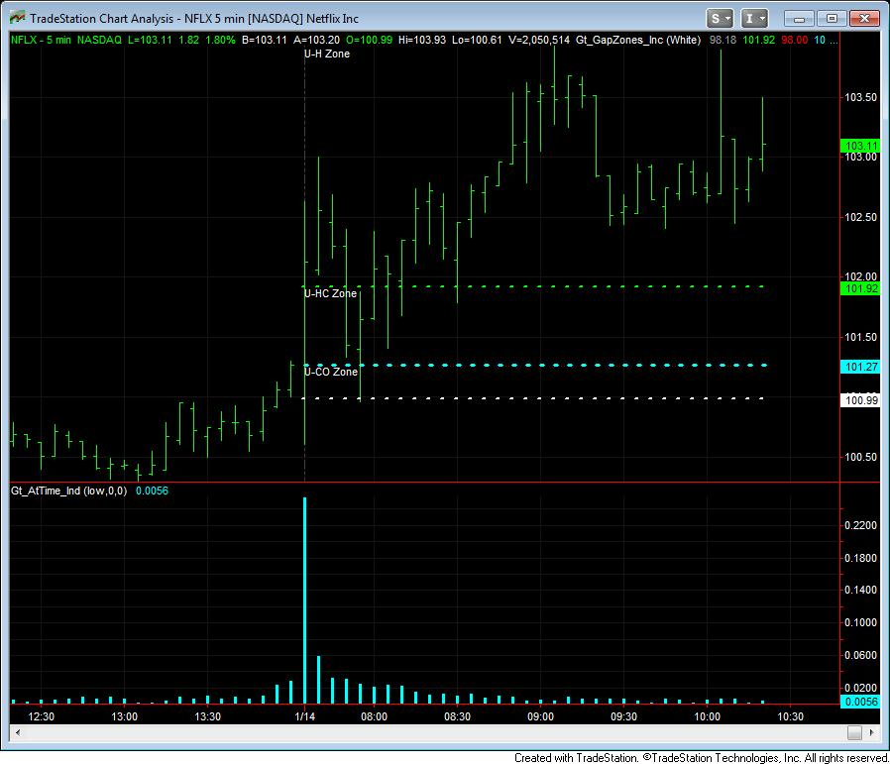
Cumulative
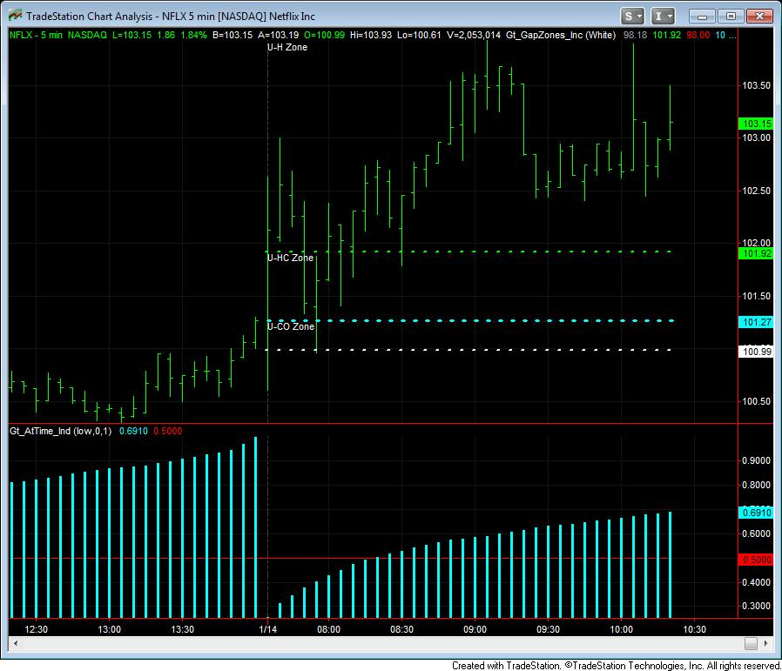

Posted - 01/14/2013 13:04:29
Oops, changed my miswording above to vertical bands, instead of horizontal. However, Grumpytrader's indicator is of definite interest and a good start, if from an oblique side, to the concept of using time as more important data than price and volume.
Human behavior is driven by time, to a surprisingly large degree, if one thinks about it. When we wake, when we eat, when we sleep, when we relax or play. And in many other ways. Human behavior drives the markets mostly. Time drives human behavior, including program trading tools used by large institutions.
Therefore, an entire class of undeveloped tool opportunities awaits - time based trade analysis, a whole different class of technical analysis. The intraday cycles spreadsheet is a good starting point towards developing these tools.

Posted - 01/18/2013 15:55:14
Got back into the saddle today, intraday trading. Today's wins using above method were LNKD, STRZA, FAS, HLF, RRC. Most did not hit the $.52 target but at least loss nothing. Small loss with MLNX.
Doubled intermediate buy and hold position in CERN, which then nicely went up a buck or so per share. Took profits in UCO intermediate term "trade". Continue to hang onto very profitable SPXL (3x ETF) intermediate term buy and hold position. These "trades" are based upon fundamentals, economics and cycles, not upon the method of this thread. Just sharing openly a bit more. FWIW there are quite a few short positions in CERN, won't take much to start a short squeeze, driving its price per share up, plus CERN normally jumps after hours on earnings announcement days, CERN invariable beats the street's estimates - next earnings date is Feb 5.
Pretty good day overall, way out of proportion to what the DOW30, Naz 100 did today. In other words, beat the crap out of the indices.
Redid the scans for symbols last night.
FWIW for those who are still having trouble with scanning - relatively low beta symbols: ALXN, FAS (ETF has no Yahoo beta), LNKD, MLNX, NFLX, REGN, RRC, SPXL (3x ETF, no beta), UCO (ETF, no beta), UPRO (ETF, no beta).
CERN, UCO, SPXL, UPRO are on my permanent trading symbols list, for intraday and longer term intervals.
BTW, beware of academics and article writers warning us via flawed research and opinions, to not hold ETFs overnight or longer. Total BS. Selecting certain multiple return ETFs often wins big, held for even weeks or months at a time. Look at charts of SPXL for example. UCO. UPRO. Many others.
Relatively moderate to high beta symbols which I sometimes trade on up days with this method, when I've unused capital leftover from prior symbols and when the day/situation "feels" like one or more of these can win: BIDU, CMI, CRM, CXO, DDD, HLF (kind of a sleeper), LULU, PXD, SHLD, SINA, STRZA, VNW. These are riskier than the low beta symbols most days.

Posted - 01/25/2013 13:50:18
Let's see. Small loss in SHLD, broke even with ALXN, using this method. Nice profits with CXO, HLF, UCO, VMW, SINA, DDD, all using this method. My guess is the day will go up near closing, so could have made money with ALXN and SHLD if that occurs, but kept to my trading rule of getting out by about 12:30 CST. Up over 17% on Jan starting capital so far.
Holding only CERN overnight, which continues up, might spurt up a fair amount if the short squeeze starts, and if earnings are good on Feb 5. Regardless, up over a buck/share from my avg price anyway.

Posted by: Zache Page 25

Input:
Barlengthtwo(2),
Barlength1(5),
Barlength2(10),
Barlength3(15),
Barlength4(20),
Barlength5(25),
Barlength6(30),
Barlength7(60),
Barlength8(120),
Barlength9(240);

Variable:
Intrabarpersist Timecalctwo(0),
Intrabarpersist Timecalc1(0),
Intrabarpersist Timecalc2(0),
Intrabarpersist Timecalc3(0),
Intrabarpersist Timecalc4(0),
Intrabarpersist Timecalc5(0),
Intrabarpersist Timecalc6(0),
Intrabarpersist Timecalc7(0),
Intrabarpersist Timecalc8(0),
Intrabarpersist Timecalc9(0),
intrabarpersist Even (0);

If Time <> time[1] then begin

Even = 0;

TimeCalctwo = Timetominutes(Time) / barlengthtwo;
If Round(Timecalctwo,0) * Barlengthtwo = Timetominutes(Time) then Even = Even+1
Else
Even = Even;

TimeCalc1 = Timetominutes(Time) / barlength1;
If Round(Timecalc1,0) * Barlength1 = Timetominutes(Time) then Even = Even+1
Else
Even = Even;

TimeCalc2 = Timetominutes(Time) / barlength2;
If Round(Timecalc2,0) * Barlength2 = Timetominutes(Time) then Even = Even+1
Else
Even = Even;

TimeCalc3 = Timetominutes(Time) / barlength3;
If (Round(Timecalc3,0) * Barlength3) = timetominutes(Time) then Even = Even +1
Else
Even = Even;

TimeCalc4 = Timetominutes(Time) / barlength4;
If Round(Timecalc4,0) * Barlength4 = Timetominutes(Time) then Even = Even+1
Else
Even = Even;

TimeCalc5 = Timetominutes(Time) / barlength5;
If Round(Timecalc5,0) * Barlength5 = Timetominutes(Time) then Even = Even+1
Else
Even = Even;

TimeCalc6 = timetominutes(Time) / barlength6;
If (Round(Timecalc6,0) * Barlength6) = timetominutes(Time) then Even = Even+1
Else
Even = Even;

TimeCalc7 = Timetominutes(Time) / barlength7;
If Round(Timecalc7,0) * Barlength7 = Timetominutes(Time) then Even = Even+1
Else
Even = Even;

TimeCalc8 = Timetominutes(Time) / barlength8;
If Round(Timecalc8,0) * Barlength8 = Timetominutes(Time) then Even = Even+1
Else
Even = Even;

TimeCalc9 = Timetominutes(Time) / barlength9;
If Round(Timecalc9,0) * Barlength9 = Timetominutes(Time) then Even = Even+1
Else
Even = Even;

end;

Plot1(Even,"Even");

Plot3(0, "Zero");

Plot4(Standardize(Ticks,30,1),"Volume");

Plot5(Standardize(Ticks,30,1),"VolumeAVG");

Posted - 02/01/2013 14:43:28
Up over 2% today (Friday)...suspect many herein are up that much or even considerably more today.
Caution: today may be a blow-out day, I think it is. Next week I expect either a strong reversal down, or markets cycling around the DOW30 14000 mark. If latter, we all can have lots of fun with this method which works superbly in a cycling, channeling market.
Because I haven't a clue what to expect come Monday, closed my open swing trade positions in CERN and UCO at about 10:30 CST when DOW30 hit +140 points.
Sitting entirely in cash...will sleep like a baby tonight, tomorrow night and Sunday night. Even if I am wrong, and miss out on profits I would have made if I had held on, I don't care, its worth the good nights' sleep.
Ed note added: Monday was indeed down a lot, good thing I did not hold anything long over the weekend. Don't like trading short in an up market, so did not enter and hold any shorts over the weekend either.

Posted - 02/01/2013 15:46:25
Total account net worth. In other words, it is ROI, assumes all of account net worth is always being used I suppose, although I am often in cash and not investing or trading anything, like right now. Only thing that matters to me is the return on my net TS account. Don't know if this is a standard, or if there is any standard. This way, am including all fees from/via TS, if any.

Posted - 02/05/2013 16:55:12
Usually February is my nemesis (devil) trading month.
But...after only 3 trading days in Feb., already total trading account net worth is up 9.4% within February alone.
How? Some intraday trading using this method. Mostly swing and intraday trading CERN and UCO 2x ETF just using fundamentals, earnings cycle and intraday cycles.
Trick now of course, will be to not give it all back by month end.

Posted - 02/07/2013 15:31:40
Sat on sidelines yesterday, felt too out of synch with the markets to trade.
Today, using this method, took a bit less than target profits in VMW, UCO, SINA, SPXL. Got out too early in SPXL which did better than the target had I stayed patient, but was nervous about the day being down so much. Missed getting into a couple three others that would have went well.
Channel traded UCO throughout the afternoon. It got incredibly flat but could be scalped. Channel traded means bought low, sold high, pennies to dime a share or so...adds up, pays some groceries. Reason I like this symbol is that I've no concerns about holding it overnight, if I can buy in at satisfactorily low prices.
Up 10.6% for the month of February. Put more capital in around mid-January and in process of adding more this month, so the YTD percentages getting tougher to achieve even as profit dollars go up. Up 24.73% YTD on current account net worth. Latter will drop with the added capital. (Hedge funds, eat your hearts out .)
[Ed. Note: These are the additional symbols which would have provided the target profit if played well: ALXN; LNKD; CERN; MLNX; RRC; UPRO; CMI; BIDU; DDD; PXD; SHLD. LNKD went crazy up in post market trading FWIW. Sure coulda done better but was way too cautious.]

Posted - 02/14/2013 12:37:48
Trading account net worth now up 13.2% half way through, for Feb (14th) alone, using this method, and another method based upon fundamentals and cycles. Sat on sidelines a couple days. Closed this morning's trades, back in total cash, taking rest of day off. Method continues to work great in channeling ("flat"), modestly down markets. If I ever learn to trade better, could have been up lot more this month. Oh, well.

Posted - 02/14/2013 17:58:43
The markets have been pretty flat for a while, so I reran my symbol selections, loosening up the parameters a little. Sharing the symbols below.
Caveat: New trading rule for this method - check the earnings schedule for symbols of individual stocks. You might skip symbols a week before earnings announcements, to avoid getting trapped by rumors and leaks which negative most of the time.
Caveat: A recent (for me) fly in the ointment is "The Motley Fool". Majority of its articles are negative. Tends to drive an individual equity symbol down for one to several days, in recent months. Tends to make its negative comments self fulfilling prophecies. Good idea to check premarket on Yahoo! for each symbol, to see if the "Fool" has just assassinated any symbols you intend to trade - whether with this method or any other.
Low beta symbols: ALXN, CERN, DECK, RRC, TDC.
(Culled out EW, EXPE, MNST, NSM, PANL, SRPT due to charts and/or news.)
(Filtered out NFLX and LINK due to high per share price but if that does not bother you, they are often profitable using this method.)
High beta symbols: CXO, FOSL, JOY, LULU, PXD, SINA, UA, WHR, WYNN.
(Culled out BIDU, CTXS, HLF, KORS, NUS, RAX, SHLD, URI, VMW as not good candidates based upon charts, news.)
ETFs: ERX, SPXL, TNA, TQQQ, UCO, UPRO, UYG.
Note that DIG, MVV and USD used to be good but their trading volumes have dropped too low. Caution with SPXL its liquidity (vol) is too low normally, but sometimes worth trading.
Ed. Notes on Feb 18: besides changes to above lists made today, Feb 18, here is a potentially nice buy and hold into post market and possibly the next day:
- SINA earnings will be announced after the close on Tuesday Feb 19 - if SINA beats the street and if its projections are good, its shares could soar in post market trading, and in premarket + opening half hour or so on Feb 20. Of course, there is the risk that SINA will disappoint.
- CXO has earnings on Feb 20, could not find at what time. Probably riskier than SINA. Be especially careful on Tuesday with CXO.
- TDC has a gap to fill and shows signs of doing so. Swing trade opportunity?

Here's a slight add-on to Kevin's KJDTimeAvgLow indicator - it now plots the earliest and the latest low times that occurred during the indicator's lookback period along with the original avg low time.
Here's the code (you may want to rename it to prevent overwriting the original):

// Indicator: KJDTimeAvgLow
//this calculates the average time of the low of the morning, for all dates in the chart
//use this with 5 minute bars
//assumes the chart is in Eastern time

//Kevin J. Davey <a href="mailto:kdavey@kjtradingsystems.com">kdavey@kjtradingsystems.com</a>
//Version 1.0
//Feb 17, 2012

// Modified by Walt W. Hooker 2/17/2012 Added Plot
// Modified by ant___ 2/20/2012 Added Earliest/Latest LODT Plots

Inputs:
LowFactor(.20), // distance below low on bar when low average time is indicated.
PrintLog(False); // true will print EL Output Log

vars:
lowtoday(99999.),
double lowtodaytime(0),
numberofdays(1),
SumLowTodayTime(0),
lowOfDaytime(0),
printToday(false),
Earliest_LODT(0),
Latest_LODT(0);

If date<>date[1] then begin
lowOfDayTime = MinutesToTime(SumLowtodayTime/NumberofDays);
Earliest_LODT = Lowest(lowOfDayTime, NumberofDays); ///Latest LODT Calcs over NumberofDays///
Latest_LODT = Highest(lowOfDayTime, NumberofDays); ///Latest LODT Calcs over NumberofDays///
lowtoday=99999.;
lowtodaytime=0; //minutes since midnight for the time of the low
numberofdays=numberofdays+1;
printToday = false;
end;

if time <=1200 then begin
if low<lowtoday then begin
lowtoday=low;
lowtodaytime=TimeToMinutes(time);
end;
end;

//at 12:05, add the lowtodaytime in to SumlowTodayTime
var:bl(" ");

if time = 1205 then begin
SumLowTodayTime=SumLowTodayTime+lowtodaytime;
print(date,bl,lowtodaytime,bl,numberofdays); //to debug
end;

if lastbaronchart and
printToday = false and
PrintLog then
begin
print(symbolname," On average, low occurs at ", lowOfDayTime);
print(symbolname, " Earliest LODT is ", Earliest_LODT, " averaged over last ", NumberofDays, " days."); ///Earliest LODT Plots///
print(symbolname, " Latest LODT is ", Latest_LODT, " averaged over last ", NumberofDays, " days."); ///Latest LODT Plots///
printToday = true;
end;

if time >= lowOfDayTime and
time[1] < lowOfDayTime then
Plot1(low - LowFactor, "LODT", white, default, 5);

///Earliest/Latest LODT Plots///
if time >= Earliest_LODT and
time[1] < Earliest_LODT then
Plot10(low - (LowFactor + 0.40), "E_LODT", white, default, 5);

if time >= Latest_LODT and
time[1] < Latest_LODT then
Plot11(low - (LowFactor + 0.80), "L_LODT", white, default, 5);

Last Post on page 29 by Tachyonv (Vince)

